Assessment: Assignment 3

Student Name: Zahi Masarwa

Lab Professor Name: Mel Sanschagrin

Lab Section Number: 303

Due Date: 03/28/21

# Understand the problem

This program will calculate if the cube that we just produce is close to perfect shape, the deference between height, length and width is with 0.1 deference. At end of the program, you have the option to print the report of how many good cubes and bad ones with the percentage of each

# Pseudocode

Class metal cube program

Start

Declare integer ENTER_DATA =1;

Declare integer REPORT =2;

Declare integer EXIT =0;

Declare class MetalCubeAnalyzer analyzer ;

Declare class UserInput input;

Declare Boolean loop=true;

While loop=true

Case based on input

Case = ENTER_DATA

Use analayzer to enter dimension

Case = REPORT

Use analyzer to print report of good cubes and bad cubes

Case = EXIT

Exit the program and loop

Loop=false

Default

Print “the number that has been selected in incorrect please enter again”

End case

End while

End

Start UserInput;

Declare scanner;

Funcation double inputDouble

Declare double =0;

While there is input

if input is double

Results=input double

Break if

Else

Scan next line

Print Number entered is not double please enter again

End while

Return result

Funcation int inputInteger

While input is not integer

Scan next line

Print Number entered is not integer please enter again

End while

Declare int result =new input

Return result

End

# Flowchart

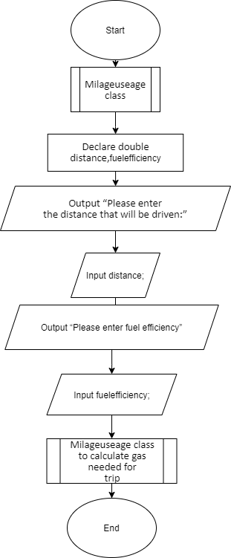

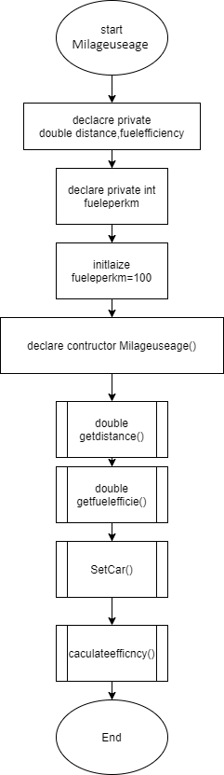

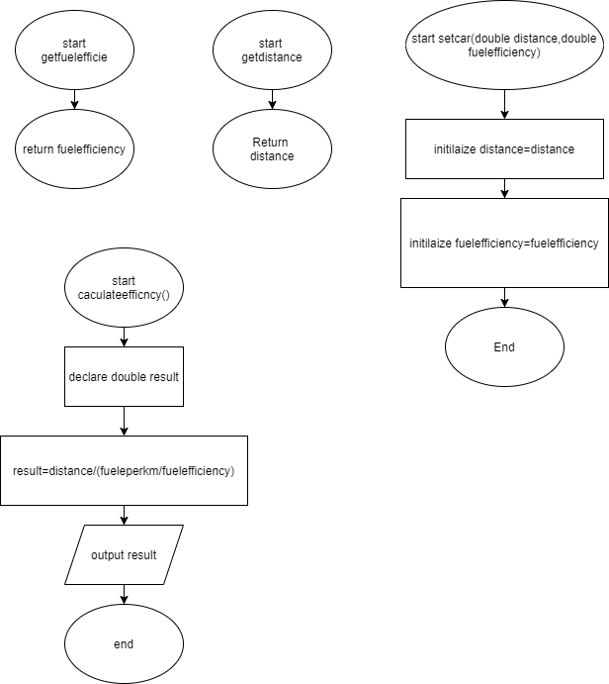

# UML

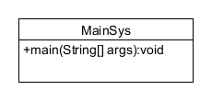

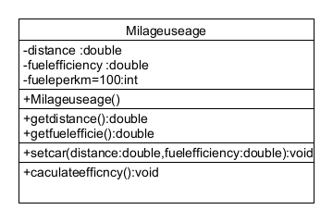

# Test Algorithm with Simple Input

|  |  |  |  |
| --- | --- | --- | --- |
| Input | Expected Output | Output | Description |
| 900,6.8 | 61 | 61 | The result has been calculated and output 61 |
| A,6.8 | Error | Error | because I entered string I got an error in output |

# Compile and Run Your Program

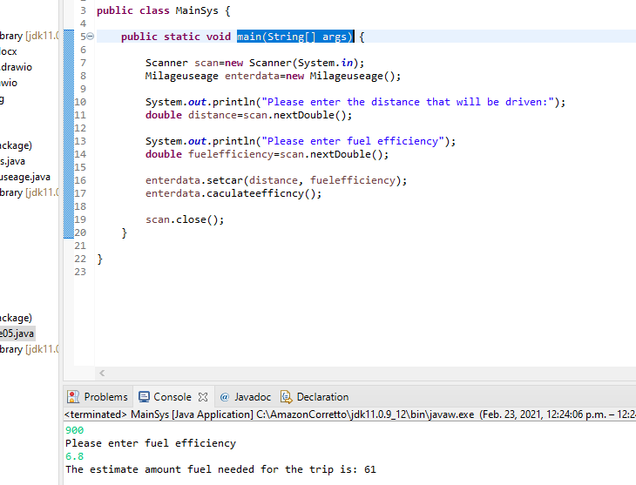

# Test Your Program

|  |  |  |  |
| --- | --- | --- | --- |
| Input | Expected Output | Output | Description |
| 900,6.8 | The estimate amount fuel needed for the trip is: 61 | The estimate amount fuel needed for the trip is: 61 | The result has been calculated and output 61 |
| A,6.8 | Error | Error | because I entered string, I got an error in output |